**To: Louisiana Council of the Blind**

_Pic6

**Re: 2012 LCB Dues**

**March 1, 2012**

**Greater New Orleans Council of the Blind dues**

_Pic19

**940 Parc Helene Drive, Marrero, LA 70072**

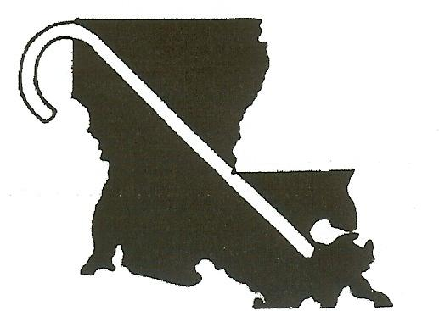

**LOUISIANA COUNCIL**

**OF THE BLIND, INC**

940 Parc Helene Drive • Marrero, LA 70072-2421 Phone: 504-328-6373 • Fax: 504-328-6372

enclosed GNOCB application along with dues to:

of GNOCB

please complete and submit the

**are $15.00.** If you are or wish to be a member

**940 Parc Helene Drive, Marrero, LA 70072**

**LCB dues are $8.00.** Please complete and submit

**,**

the enclosed LCB application along with dues to:

**Dues for 2012** are due no later than Thursday

Date: January 10, 2012

**Capital City Council of the Blind dues are**

**$12.00**. If you are or wish to be a member of

_Pic57

CCCB,

please complete and submit the enclosed

CCCB application along with dues to:

**763 South 12th Street, Baton Rouge, LA** 70802

Please note:

Membership in either GNOCB or

CCCB Includes membership in

Louisiana Council of the Blind.

Membership in LCB includes

membership in

American Council of the Blind.

**Membership Application**

I am applying for membership in the Louisiana

Council of the Blind, Inc. I

understand that membership in the Council and payment of LCB dues entitles me to  
membership in the American Council of the Blind.

**NAME**

**ADDRESS**

**CITY/STATE/ZIP**

**TELEPHONE HOME**

**WORK**

**CELL PHONE**

**FAX**

**E-MAIL ADDRESS**

**Totally Blind**

**I am (circle one) Visually Impaired**

**Sighted**

**Format, LCB Material (circle one)**

**E-Mail**

**Braille**

**Large Print**

**Braille**

**Large Print**

**Braille Forum (circle one)**

**Cassette**

**E-Mail**

Signature

Date

**Enclosed is my check, payable to LCB, for $8.00**



**Blind, Inc.**

**Council of the**

**Louisiana**

940 Parc Helene Drive Marrero, LA 70072-2421  
Phone: (504) 348-0003 Fax: (504) 328-6372